Chapter 19 Concrete
CALIFORNIA BUILDING CODE — MATRIX ADOPTION TABLE
CHAPTER 19 — CONCRETE
(Matrix Adoption Tables are nonregulatory, intended only as an aid to the code user.
See Chapter 1 for state agency authority and building applications.)
Adopting agency | BSC | BSC-CG | SFM | HCD |  |  | DSA |  |  | OSHPD |  |  |  |  |  |  | BSCC | DPH | AGR | DWR | CEC | CA | SL | SLC
 |  |  |  | 1 | 2 | 1/AC | AC | SS | SS/CC | 1 | 1R | 2 | 3 | 4 | 5 | 6
Adopt entire chapter | X |  |  |  | X |  |  |  |  |  |  |  | X |  |  | X
Adopt entire chapter as  amended (amended  sections listed below) |  |  |  | X |  |  |  |  | X |  | X | X |  |  | X
Adopt only those sections
that are listed below
Chapter / Section
1901.1.1 |  |  |  |  |  |  |  |  | X |  | X | X |  |  | X
1901.1.2 |  |  |  |  |  |  |  |  | X |  | X | X |  |  | X
1901.1.3 |  |  |  |  |  |  |  |  | X |  | X | X |  |  | X
1901.1.4 |  |  |  |  |  |  |  |  | X
1901.1.5 |  |  |  |  |  |  |  |  | X
1901.3.1 — 1901.3.4.5 |  |  |  |  |  |  |  |  |  |  | X | X |  |  | X
1903.1 |  |  |  |  |  |  |  |  |  |  | X | X |  |  | X
1903.3 |  |  |  |  |  |  |  |  |  |  | X | X |  |  | X
1903.4 |  |  |  |  |  |  |  |  |  |  | X | X |  |  | X
1903.5 |  |  |  |  |  |  |  |  |  |  | X | X |  |  | X
1905.1.8
1905.5 |  |  |  |  |  |  |  |  |  |  | X | X |  |  | X
1905.6 |  |  |  |  |  |  |  |  |  |  | X | X |  |  | X
1906 |  |  |  |  |  |  |  |  |  |  | X | X |  |  | X
1907.4.1 |  |  |  | X
1908.1 |  |  |  |  |  |  |  |  |  |  | X | X |  |  | X
1909 |  |  |  |  |  |  |  |  | X
1910 |  |  |  |  |  |  |  |  |  |  | X | X |  |  | X
1911 |  |  |  |  |  |  |  |  |  |  | X | X |  |  | X
The state agency does not adopt sections identified with the following symbol: †
The Office of the State Fire Marshal's adoption of this chapter or individual sections is applicable to structures regulated by other state agencies pursuant to Section 1.11.
User notes:
About this chapter: Chapter 19 provides minimum accepted practices for the design and construction of buildings and structural components using concrete—both plain and reinforced. Chapter 19 relies primarily on the reference to American Concrete Institute (ACI) 318, Building Code Requirements for Structural Concrete. Structural concrete must be designed and constructed to comply with this code and all listed standards. There are also specific provisions addressing slabs-on-ground and shotcrete.
This chapter was extensively reorganized for the 2024 edition. For complete information, see the relocations table in the Preface information of this code.
ICC code development note: Code change proposals to this chapter will be considered by the IBC—Structural Code Development Committee during the 2025 (Group B) Code Development Cycle.
Section 1901 General
Diagram
UpCodes Diagrams (26)
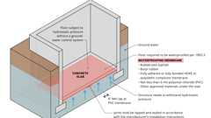
Subgrade Floor Waterproofing
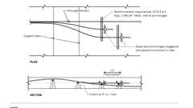
Anchorage of Added Tendon
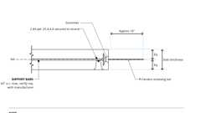
PT: Stressing End Anchor Showing Added #4 Bars at Distributed Tendons
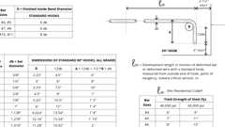
Standard Hooks in Tension
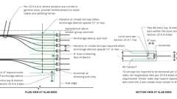
Anchorage Zone Reinforcement: Banded Tendons
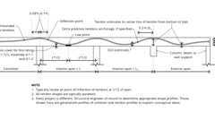
Typical Distributed Tendon Profile - Slab
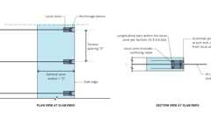
General and Local Anchorage Zones
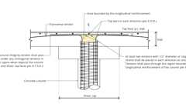
Structural Integrity Tendons
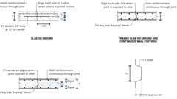
Concrete Construction Joint
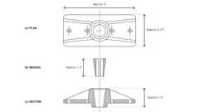
PT: Generic Monostrand Anchorage
Show 16 more
1901.1 Scope
The provisions of this chapter shall govern the materials, quality control, design and construction of concrete used in structures.
1901.1.1 Application
[DSA-SS/CC, OSHPD] The scope of application of Chapter 19 is as follows:
- Structures regulated by the Division of the State Architect—Structural Safety/Community Colleges (DSA-SS/CC), which include those applications listed in Section 1.9.2.2.
- Structures regulated by the Department of Health Care Access and Information/Office of Statewide Hospital Planning and Development (OSHPD), which include hospital buildings removed from general acute care service, skilled nursing facility buildings, intermediate care facility buildings and acute psychiatric hospital buildings listed in Sections 1.10.1, 1.10.2 and 1.10.5.
1901.1.2 Amendments in This Chapter
[DSA-SS/CC, OSHPD] DSA-SS/CC and OSHPD adopts this chapter as amended.
1901.1.3 Identification of Amendments. [DSA-SS/CC, OSHPD]
- Division of the State Architect - Structural Safety/Community Colleges amendments appear in this chapter preceded by the appropriate acronym, as follows:
  - [DSA-SS/CC] — For applications listed in Section 1.9.2.2.
- [OSHPD 1R, 2 & 5] Office of Statewide Hospital Planning and Development (OSHPD) amendments appear in this chapter preceded by the appropriate acronym, as follows:
  - [OSHPD 1R] — For applications listed in Section 1.10.1.
  - [OSHPD 2] — For applications listed in Section 1.10.2.
  - [OSHPD 5] — For applications listed in Section 1.10.5.
1901.1.4 Reference to Other Chapters
[DSA-SS/CC] Where reference within this chapter is made to sections in Chapters 17 and 18, the provisions in Chapters 17A and 18A respectively shall apply instead.
1901.1.5 Additional Amendments
[DSA-SS/CC] See Section 1909 for additional requirements.
1901.2 Plain and Reinforced Concrete
Assembly
Diagram
Structural concrete shall be designed and constructed in accordance with the requirements of this chapter and ACI 318 as supplemented in Section 1905 of this code.
UpCodes Diagrams (17)
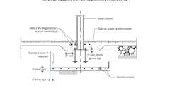
Interior Column on Footing w/o Pier
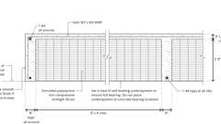
Typical Raised Slab over Foam
Concrete Construction Joint
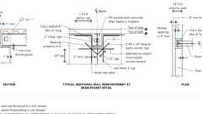
Beam Pocket
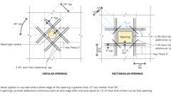
Concrete Wall Openings Reinforcement
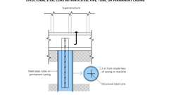
Min. Conc. Cover: Steel Core in Cased Pier
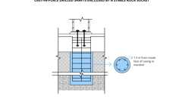
Min. Conc. Cover: Cast-in-place, Rock Socket
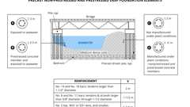
Min. Conc. Cover: Deep Precast Found. Elements
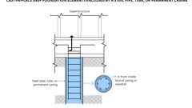
Min. Conc. Cover: Cased Deep Foundations
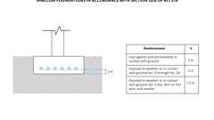
Min. Conc. Cover: Shallow Foundations
Show 7 more
Assemblies (46)
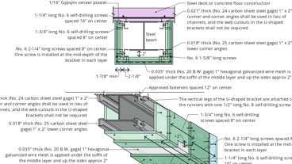
2-4.2: 3hr, Steel Beam, Gypsum - Alt.
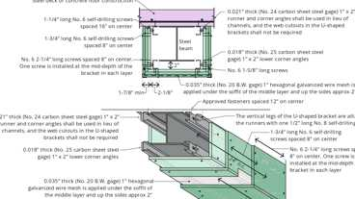
2-4.2: 3hr, Steel Beam, Gypsum
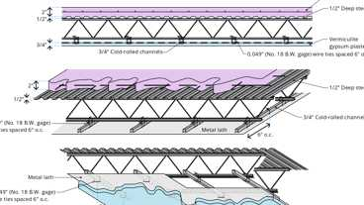
8-1.1: 4hr Steel
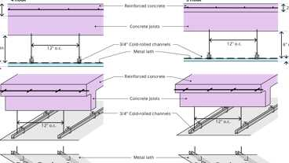
5-1.1: 3hr & 4hr, Reinforced conc.
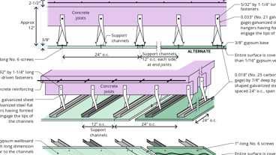
5-2.1: 2hr Reinforced conc.
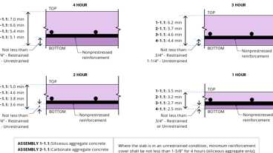
1-1.1 Through 4-1.1: Concrete Slab
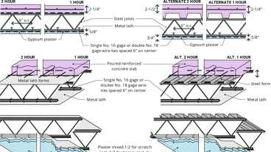
6-1.1: 1hr & 2hr, Steel
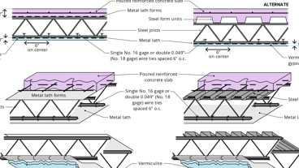
6-2.1: 3hr Steel
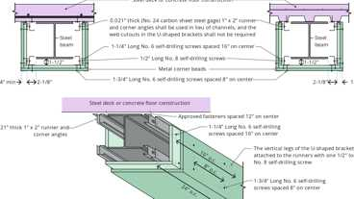
2-4.1: 2hr, Steel Beam, Gypsum - Alternate
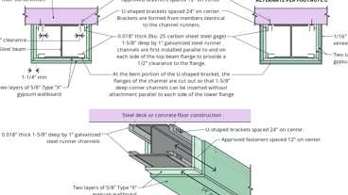
2-4.1: 2hr, Steel Beam, Gypsum
Show 36 more
1901.2.1 Structural Concrete With GFRP Reinforcement
Cast-in-place structural concrete internally reinforced with glass fiber reinforced polymer (GFRP) reinforcement conforming to ASTM D7957 and designed in accordance with ACI CODE 440.11 shall be permitted where fire-resistance ratings are not required and only for structures assigned to Seismic Design Category A.
1901.3 Anchoring to Concrete
Diagram
Anchoring to concrete shall be in accordance with ACI 318 as supplemented in Section 1905, and applies to cast-in (headed bolts, headed studs and hooked J- or L-bolts), post-installed expansion (torque-controlled and displacement-controlled), undercut, screw, and adhesive anchors.
UpCodes Diagrams (5)
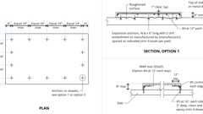Primary
Example: Concrete Equipment Pad
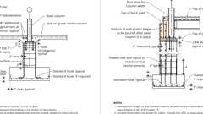
Example: Steel Column to Conc. Pedestal / Footing
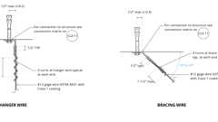
Suspended Ceiling Bracing Wires
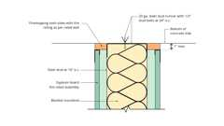
Example: Interior Metal Stud Partition / Concrete Slab Firestopping
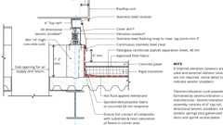
Example: Liquid-Applied Roofing at Rooftop Unit Curb Support
1901.3.1 Power Actuated Fasteners
[OSHPD 1R, 2 & 5] Power actuated fasteners qualified in accordance with ICC-ES AC 70 shall be deemed to satisfy the requirements of ASCE 7, Section 13.4.5.
Power actuated fasteners shall be permitted in seismic shear for components exempt from construction documents review by ASCE 7, Section 13.1.4 and for interior non-bearing non-shear wall partitions only. Power actuated fastener shall not be used to anchor seismic bracing, exterior cladding or curtain wall systems.
Exception: Power actuated fasteners in steel to steel connections prequalified for seismic application by cyclic tests in accordance with ICC-ES AC 70 shall be permitted for seismic design.
1901.3.2 Mechanical Anchors and Specialty Inserts
[OSHPD 1R, 2 & 5] Mechanical anchors qualified in accordance with ICC-ES AC 193 shall be deemed to satisfy the requirements of this section. Specialty inserts, including cast-in-place specialty inserts, tested in accordance with ICC-ES AC 232 or AC 446 shall be deemed to satisfy the requirements of this section.
Note: The removal and resetting of post-installed mechanical anchors are prohibited by ACI 318 Section 17.1.3.
1901.3.3 Post-Installed Adhesive Anchors
[OSHPD 1R, 2 & 5] Post-installed reinforcing bars, adhesive anchors, and torquecontrolled adhesive anchors qualified in accordance with ICC-ES AC 308 shall be deemed to satisfy the requirements of this section.
1901.3.4 Proof Tests for Post-Installed Anchors in Concrete
[OSHPD 1R, 2 & 5] When post-installed anchors are used in lieu of cast-in place bolts, the proof test loads, frequency and acceptance criteria shall be in accordance with this section.
Exceptions: Proof tests are not required for the following:
- Undercut anchors that allow visual confirmation of full set.
- Repetitively installed anchors (with three or more identical anchors) of diameter one-quarter (¹/₄) inch or less used for distributed systems or architectural components.
- Power actuated fasteners used to attach tracks of interior nonstructural partition walls resisting only shear loads and with at least three fasteners per segment of track.
- Shear dowels across cold joints in slabs on grade, where the slab is not structural in accordance with Section 1907.1.
1901.3.4.1 General
[OSHPD 1R, 2 & 5] Test loads or torques, test frequencies, and acceptance criteria shall be shown on the construction documents.
If any anchor fails testing, all anchors of the same type shall be tested until twenty (20) consecutive anchors pass, then resume the initial test frequency.
Anchors to be tested shall be selected at random by the special inspector or inspector of record (IOR) when 100 percent of the anchors are not tested.
The testing of the post-installed anchors shall be done in the presence of the special inspector and a report of the test results shall be submitted to the enforcement agency.
1901.3.4.2 Proof Testing Procedure
[OSHPD 1R, 2 & 5] Post-installed anchors shall be tension tested in accordance with ASTM E3121 with test frequency and test loads in accordance with Sections 1901.3.4.3 and 1901.3.4.4, respectively. Proof tests using ASTM E3121 tension test procedure do not require displacement measurement.
Exception: Torque-controlled post-installed and screw-type anchors shall be permitted to be tested using torque based on a valid evaluation report using criteria adopted in this code.
1901.3.4.3 Test Frequency
[OSHPD 1R, 2 & 5]
1901.3.4.3.1 Structural Applications
One hundred percent of post-installed anchors used for sructural applications shall be proof tested.
Exceptions:
- Sill bolts. When post-installed anchors are used for sill plate or bottom track bolting applications, 10 percent of the anchors shall be tested.
- Rebar dowels. When adhesive anchor systems are used to install reinforcing dowel bars in hardened concrete, 25 percent of dowels shall be tested if all the following conditions are met:
  - The dowels are used exclusively to transmit shear forces across joints between existing and new concrete.
  - The number of dowels in any one member equals or exceeds twelve (12).
  - The dowels are uniformly distributed across seismic force resisting members (such as shear walls, collectors and diaphragms).
1901.3.4.3.2 Nonstructural Applications
Fifty percent of post-installed anchors used in nonstructural applications shall be proof tested. The percentage of tested anchors applies to each set of anchors of a common type (e.g., adhesive, wedge, or shell and sleeve for expansion bolts), size, and embedment depth and to each group of anchors. Four or more anchors connected to a common element shall be defined as a group.
Exceptions:
- Repetitive anchors. When anchors are used repetitively (with three or more identical anchors) in distribution systems (such as pipe, duct or conduit supports) or architectural systems (such as suspended ceilings, cladding, and partitions), 20 percent of anchors, including at least one anchor in each group, shall be tested.
- Anchors with low tension. When the design tension on anchors is less than 100 pounds and those anchors are clearly noted on the approved construction documents, 10 percent of anchors shall be tested.
1901.3.4.4 Test Loads
[OSHPD 1R, 2 & 5] Required test loads shall be determined by one of the following methods:
- Twice the maximum allowable tension load or one and a quarter (1¹/₄) times the maximum design strength of anchors as provided in approved evaluation report using criteria adopted in this code or determined in accordance with Chapter 17 of ACI 318.
Tension test load need not exceed 80 percent of the nominal yield strength of the anchor element (= 0.8 A_{se} f_{ya}).
- The manufacturer's recommended installation torque based on approved evaluation report using criteria adopted in this code.
1901.3.4.5 Test Acceptance Criteria
[OSHPD 1R, 2 & 5] Proof test shall satisfy the following minimum requirements.
- Tension test: Anchors shall be tested in the unconfined condition in accordance with ASTM E3121 except that the minimum clearance to the test frame shall be 1.5 times the anchor's embedment depth. Test load shall be maintained for a minimum of 15 seconds and shall exhibit no discernable movement during the tension test, e.g., as evidenced by loosening of the washer under the nut or an abrupt decrease in the gauge pressure.
Exception: Adhesive anchors shall be permitted to be tested in confined conditions in accordance with ASTM E3121 when the approved construction documents indicate that concrete breakout does not control the design tensile strength.
- Torque test:
Torque-controlled post-installed anchors tested with a calibrated torque wrench shall attain the specified torque within ¹/₂ turn of the nut; or one-quarter (¹/₄) turn of the nut for a ³/₈-inch sleeve anchor only.
Screw-type anchors tested with a calibrated torque wrench shall attain the specified torque within one-quarter (¹/₄) turn of the screw after initial seating of the screw head.
1901.4 Composite Structural Steel and Concrete Structures
Systems of structural steel acting compositely with reinforced concrete shall be designed in accordance with Section 2206 of this code.
1901.5 Construction Documents
Diagram
The construction documents for structural concrete construction shall include:
- The specified compressive strength of concrete at the stated ages or stages of construction for which each concrete element is designed.
- The specified strength or grade of reinforcement.
- The size and location of structural elements, reinforcement and anchors.
- Provision for dimensional changes resulting from creep, shrinkage and temperature.
- The magnitude and location of prestressing forces.
- Anchorage length of reinforcement and location and length of lap splices.
- Type and location of mechanical and welded splices of reinforcement.
- Details and location of contraction or isolation joints specified for plain concrete.
- Minimum concrete compressive strength at time of posttensioning.
- Stressing sequence for posttensioning tendons.
- For structures assigned to Seismic Design Category D, E or F, a statement if slab on grade is designed as a structural diaphragm.
UpCodes Diagrams (2)
Standard Hooks in Tension
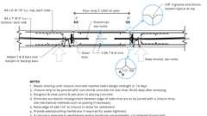
Example - Closure Strip
1901.6 Special Inspections and Tests
Special inspections and tests of concrete elements of buildings and structures and concreting operations shall be as required by Chapter 17.
1901.7 Tolerances for Structural Concrete
Where not indicated in construction documents, structural tolerances for concrete structural elements shall be in accordance with this section.
1901.7.1 Cast-in-Place Concrete Tolerances
Structural tolerances for cast-in-place concrete structural elements shall be in accordance with ACI 117.
Exceptions:
- Group R-3 detached one- or two-family dwellings are not required to comply with this section.
- Shotcrete is not required to comply with this section.
1901.7.2 Precast Concrete Tolerances
Structural tolerances for precast concrete structural elements shall be in accordance with ACI ITG-7.
Exception: Group R-3 detached one- or two-family dwellings are not required to comply with this section.
Section 1902 Coordination of Terminology
1902.1 General
Coordination of terminology used in ACI 318 and ASCE 7 shall be in accordance with Section 1902.1.1.
1902.1.1 Design Displacement
Design displacement shall be the Design Earthquake Displacement, δ_{DE}, defined in ASCE 7 Section 12.8.6.3. For diaphragms that can be idealized as rigid in accordance with ASCE 7 Section 12.3.1.2, δ_{di}, displacement due to diaphragm deformation corresponding to the design earthquake, is permitted to be taken as zero.
Section 1903 Specifications for Tests and Materials
1903.1 General
Materials used to produce concrete, concrete itself and testing thereof shall comply with the applicable standards listed in ACI 318.
Exception: The following standards as referenced in Chapter 35 shall be permitted to be used.
- ASTM C150
- ASTM C595
- ASTM C1157
1903.2 Glass Fiber-Reinforced Concrete
Assembly
Glass fiber-reinforced concrete (GFRC) and the materials used in such concrete shall be in accordance with the PCI 128.
Assemblies (2)
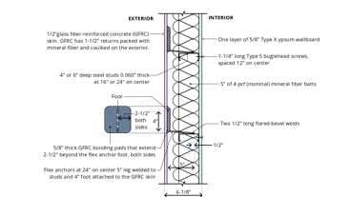
15-1.11: 1hr, Steel Studs w/GFRC
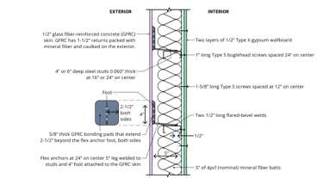
15-1.10: 2hr, Steel Studs w/ GFRC
1903.3 Flat Wall Insulating Concrete Form (ICF) Systems
Insulating concrete form material used for forming flat concrete walls shall conform to ASTM E2634. [OSHPD 1R, 2 & 5] Not Permitted by OSHPD.
1903.4 Steel Fiber Reinforcement -
[OSHPD 1R, 2 & 5] Not permitted by OSHPD.
1903.5 Welding of Reinforcing Bars -
[OSHPD 1R, 2 & 5] Modify ACI 318 Section 26.6.4.1(b) by adding the following:
- Subject to prior approval of the enforcing agency, longitudinal holding wires conforming to ASTM A1064, of maximum wire size W5, that are machine resistance welded to stirrup/tie cage (or spiral assemblies) consisting of low alloy steel reinforcing conforming to ASTM A706 are permitted when performed under continuous competent control in a fabrication shop. Tack welding of primary reinforcing bars together or to stirrups/ties is not permitted. Holding wire weld locations shall not occur on any longitudinal or primary reinforcing nor on any portion of a reinforcing bar that is or will be bent in accordance with ACI 318 Section 25.3 for the extents specified in AWS D1.4 Section 4.2.6.
  - Quality control tests shall be performed on shop welded specimens by the fabricator. Reinforcing steel specimens containing the holding wire shall be tested for yield and tensile strength at the frequency required by Section 1910.2. Test reports shall be available on request to the approved agency, design professional and enforcement agency.
Section 1904 Durability Requirements
Diagram
UpCodes Diagram (1)
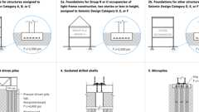
Min. Specified Concrete Strength for Foundations
1904.1 Structural Concrete
Diagram
Structural concrete shall conform to the durability requirements of ACI 318.
Exception: For Group R-2 and R-3 occupancies not more than three stories above grade plane, the specified compressive strength, f´, for concrete in basement walls, foundation walls, exterior walls and other vertical surfaces exposed to the weather shall be not less than 3,000 psi (20.7 MPa).
UpCodes Diagrams (2)
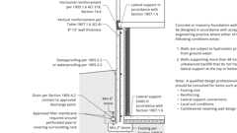
Prescriptive Foundation Wall and Drain
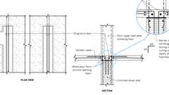
Example: Construction Slip Joint at Concrete Shear Wall
1904.2 Nonstructural Concrete
The registered design professional shall assign nonstructural concrete a freeze-thaw exposure class, as defined in ACI 318, based on the anticipated exposure of nonstructural concrete. Nonstructural concrete shall have a minimum specified compressive strength, f´_{c}, of 2,500 psi (17.2 MPa) for Class F0; 3,000 psi (20.7 MPa) for Class F1; and 3,500 psi (24.1 MPa) for Classes F2 and F3. Nonstructural concrete shall be air entrained in accordance with ACI 318.
Section 1905 Seismic Requirements
1905.1 General
In addition to the provisions of ACI 318, structural concrete shall comply with the requirements of Section 1905.
1905.2 ACI 318 Section 2.3
Modify existing definitions and add the following definitions to ACI 318 Section 2.3:
CAST-IN-PLACE CONCRETE EQUIVALENT DIAPHRAGM. A cast-in-place noncomposite topping slab diaphragm, as defined in Section 18.12.5, or a diaphragm constructed with precast concrete components that uses closure strips between precast components with detailing that meets the requirements of ACI 318 for the Seismic Design Category of the structure.
DETAILED PLAIN CONCRETE STRUCTURAL WALL. A wall complying with the requirements of Chapter 14, and Section 1905.5 of the California Building Code.
ORDINARY PLAIN CONCRETE STRUCTURAL WALL. A wall complying with the requirements of Chapter 14, excluding 14.6.2.
ORDINARY PRECAST STRUCTURAL WALL. A precast wall complying with the requirements of Chapters 1 through 13, 15, 16 and 19 through 26.
ORDINARY REINFORCED CONCRETE STRUCTURAL WALL. A cast-in-place wall complying with the requirements of Chapters 1 through 13, 15, 16 and 19 through 26.
PRECAST CONCRETE DIAPHRAGM. A diaphragm constructed with precast concrete components, with or without a cast-in-place topping, that includes the use of discrete connectors or joint reinforcement to transmit diaphragm forces.
1905.3 Intermediate Precast Structural Walls
Intermediate precast structural walls shall comply with Section 18.5 of ACI 318 and this section.
1905.3.1 Connections Designed to Yield
Connections that are designed to yield shall be capable of maintaining 80 percent of their design strength at the deformation induced by the design displacement or shall use Type 2 mechanical splices.
1905.4 Foundations Designed to Resist Earthquake Forces
Foundations resisting earthquake-induced forces or transferring earthquake-induced forces between a structure and the ground shall comply with the requirements of Section 18.13 of ACI 318 and other applicable provisions of ACI 318 unless modified by Chapter 18.
1905.5 Detailed Plain Concrete Structural Walls
Detailed plain concrete structural walls are walls conforming to the requirements of ordinary plain concrete structural walls and Section 1905.5.1. [OSHPD 1R, 2 & 5] Plain concrete shall not be permitted.
1905.5.1 Reinforcement
Reinforcement shall be provided as follows:
- Vertical reinforcement of not less than 0.20 square inch (129 mm²) in cross-sectional area shall be provided continuously from support to support at each corner, at each side of each opening, and at the ends of walls. The continuous vertical bar required beside an opening is permitted to substitute for one of the two No. 5 bars required by Section 14.6.1 of ACI 318.
- Horizontal reinforcement of not less than 0.20 square inch (129 mm²) in cross-sectional area shall be provided:
  - 2.1. Continuously at structurally connected roof and floor levels and at the top of walls.
  - 2.2. At the bottom of load-bearing walls or in the top of foundations where doweled to the wall.
  - 2.3. At a maximum spacing of 120 inches (3048 mm).
Reinforcement at the top and bottom of openings, where used in determining the maximum spacing specified in Item 2.3, shall be continuous in the wall.
1905.6 Structural Plain Concrete
Structural plain concrete elements shall comply with this section in lieu of Section 14.1.4 of ACI 318. [OSHPD 1R, 2 & 5] Plain concrete shall not be permitted.
1905.6.1 Seismic Design Categories A and B
In structures assigned to Seismic Design Category A or B, detached one- and two-family dwellings three stories or less in height constructed with stud-bearing walls are permitted to have plain concrete footings without longitudinal reinforcement.
1905.6.2 Seismic Design Categories C, D, E and F
Structures assigned to Seismic Design Category C, D, E or F shall not have elements of structural plain concrete, except as follows:
- Structural plain concrete basement, foundation or other walls below the base as defined in ASCE/SEI 7 are permitted in detached one- and two-family dwellings three stories or less in height constructed with stud-bearing walls. In dwellings assigned to Seismic Design Category D or E, the height of the wall shall not exceed 8 feet (2438 mm), the thickness shall be not less than 7¹/₂ inches (190 mm), and the wall shall retain not more than 4 feet (1219 mm) of unbalanced fill. Walls shall have reinforcement in accordance with Section 14.6.1 of ACI 318.
- Isolated footings of plain concrete supporting pedestals or columns are permitted, provided that the projection of the footing beyond the face of the supported member does not exceed the footing thickness.
Exception: In detached one- and two-family dwellings three stories or less in height, the projection of the footing beyond the face of the supported member is permitted to exceed the footing thickness.
- Plain concrete footings supporting walls are permitted, provided that the footings have not fewer than two continuous longitudinal reinforcing bars. Bars shall not be smaller than No. 4 and shall have a total area of not less than 0.002 times the gross cross-sectional area of the footing. For footings that exceed 8 inches (203 mm) in thickness, not fewer than one bar shall be provided at the top and bottom of the footing. Continuity of reinforcement shall be provided at corners and intersections.
Exceptions:
  - Where assigned to Seismic Design Category C, detached one- and two-family dwellings three stories or less in height constructed with stud-bearing walls are permitted to have plain concrete footings without longitudinal reinforcement.
  - For foundation systems consisting of a plain concrete footing and a plain concrete stemwall, not fewer than one bar shall be provided at the top of the stemwall and at the bottom of the footing.
  - Footings cast monolithically with a slab-on-ground shall have not fewer than one No. 4 bar at the top and bottom of the footing or one No. 5 bar or two No. 4 bars in the middle third of the footing depth.
1905.7 Design Requirements for Anchors
For the design requirements for anchors, Sections 1905.7.1 and 1905.7.2 provide exceptions that are permitted to ACI 318.
1905.7.1 Anchors in Tension
The following exception is permitted to ACI 318 Section 17.10.5.2:
Exception: Anchors designed to resist wall out-of-plane forces with design strengths equal to or greater than the force determined in accordance with ASCE/SEI 7 Equation 12.11-1 or 12.14-1 shall be deemed to satisfy Section 17.10.5.3(d) of ACI 318.
1905.7.2 Anchors in Shear
The following exceptions are permitted to ACI 318 Section 17.10.6.2:
Exceptions:
- For the calculation of the in-plane shear strength of anchor bolts attaching wood sill plates of bearing or nonbearing walls of light-frame wood structures to foundations or foundation stemwalls, the in-plane shear strength in accordance with Sections 17.7.2 and 17.7.3 of ACI 318 need not be computed and Section 17.10.6.3 of ACI 318 shall be deemed to be satisfied provided that all of the following are met:
  - The allowable in-plane shear strength of the anchor is determined in accordance with ANSI/AWC NDS Table 12E for lateral design values parallel to grain.
  - The maximum anchor nominal diameter is ⁵/₈ inch (16 mm).
  - Anchor bolts are embedded into concrete not less than 7 inches (178 mm).
  - Anchor bolts are located not less than 1³/₄ inches (45 mm) from the edge of the concrete parallel to the length of the wood sill plate.
  - Anchor bolts are located not less than 15 anchor diameters from the edge of the concrete perpendicular to the length of the wood sill plate.
  - The sill plate is 2-inch (51 mm) or 3-inch (76 mm) nominal thickness.
- For the calculation of the in-plane shear strength of anchor bolts attaching cold-formed steel track of bearing or nonbearing walls of light-frame construction to foundations or foundation stemwalls, the in-plane shear strength in accordance with Sections 17.7.2 and 17.7.3 of ACI 318 need not be computed and 17.10.6.3 shall be deemed to be satisfied provided that all of the following are met:
Allowable in-plane shear strength of exempt anchors, parallel to the edge of concrete, shall be permitted to be determined in accordance with AISI S100 Section J3.3.1.
  - The maximum anchor nominal diameter is ⁵/₈ inch (16 mm).
  - Anchors are embedded into concrete a minimum of 7 inches (178 mm).
  - Anchors are located a minimum of 1³/₄ inches (45 mm) from the edge of the concrete parallel to the length of the track.
  - Anchors are located a minimum of 15 anchor diameters from the edge of the concrete perpendicular to the length of the track.
  - The track is 33 to 68 mil (0.84 mm to 1.73 mm) designation thickness.
- In light-frame construction bearing or nonbearing walls, shear strength of concrete anchors less than or equal to 1 inch (25 mm) in diameter attaching sill plate or track to foundation or foundation stemwalls need not satisfy Sections 17.10.6.3(a) through (c) when the design strength of the anchors is determined in accordance with Section 17.7.2.1(c) of ACI 318.
Section 1906 Footings for Light-Frame Construction
[OSHPD 1R, 2 & 5] Plain concrete footings not permitted by OSHPD.
1906.1 Plain Concrete Footings
For Group R-3 occupancies and buildings of other occupancies less than two stories above grade plane of light-frame construction, the required thickness of plain concrete footings is permitted to be 6 inches (152 mm), provided that the footing does not extend more than 4 inches (102 mm) on either side of the supported wall.
Section 1907 Slabs-on-Ground
1907.1 Structural Slabs-on-Ground
Structural concrete slabs-on-ground shall comply with all applicable provisions of this chapter. Slabs-on-ground shall be considered structural concrete where required by ACI 318 or where designed to transmit either of the following:
- Vertical loads or lateral forces from other parts of the structure to the soil.
- Vertical loads or lateral forces from other parts of the structure to foundations.
1907.2 Nonstructural Slabs-on-Ground
Nonstructural slabs-on-ground shall be required to comply with Sections 1904.2, 1907.3 and 1907.4. Portions of the nonstructural slabs-on-ground used to resist uplift forces or overturning shall be designed in accordance with accepted engineering practice throughout the entire portion designated as dead load to resist uplift forces or overturning.
1907.3 Thickness
The thickness of concrete floor slabs supported directly on the ground shall be not less than 3¹/₂ inches (89 mm).
1907.4 Vapor Retarder
A 6-mil (0.006 inch; 0.15 mm) polyethylene vapor retarder with joints lapped not less than 6 inches (152 mm) shall be placed between the base course or subgrade and the concrete floor slab, or other approved equivalent methods or materials shall be used to retard vapor transmission through the floor slab.
Exception: A vapor retarder is not required:
- For detached structures accessory to occupancies in Group R-3, such as garages, utility buildings or other unheated facilities.
- For unheated storage rooms having an area of less than 70 square feet (6.5 m²) and carports attached to occupancies in Group R-3.
- For buildings of other occupancies where migration of moisture through the slab from below will not be detrimental to the intended occupancy of the building.
- For driveways, walks, patios and other flatwork that will not be enclosed at a later date.
- Where approved based on local site conditions.
1907.4.1 [HCD 1] Capillary Break
When a vapor retarder is required, a capillary break shall be installed in accordance with the California Green Building Standards Code (CALGreen), Chapter 4, Division 4.5.
Section 1908 Shotcrete
1908.1 General
Shotcrete shall be in accordance with the requirements of ACI 318. [OSHPD 1R, 2 & 5] and the provisions of ACI 506R.
Preconstruction tests of one or more shotcrete mockup panels prepared in accordance with Section 1705.3.9.2 are required. In addition to testing requirements in ACI 318, special inspection and testing shall be in accordance with Section 1705.3.9.
The evaluation of the shotcrete mockup panel to qualify bar clearance dimensions in accordance with ACI 318 Section 25.2.7 or contact lap splices in accordance with ACI 318 Section 25.5.1.7 shall be in accordance with the requirements of ACI 506.4R with a core quality category of Very Good given in ACI 506.6T.
Shotcrete construction shall be in accordance with the requirements of ACI 506.2.
Section 1909 Additional Requirements for Community Colleges [DSA-SS/CC]
1909.1 General
1909.1.1 Construction Documents
Openings larger than 12 inches (305 mm) in any dimension shall be detailed on the structural drawings.
1909.2 Tests and Materials
Where required, special inspections and tests shall be in accordance with Chapter 17A and this section.
1909.2.1 Steel Fiber Reinforcement
Not permitted.
1909.2.2 Cementitious Material
The concrete supplier shall furnish to the enforcement agency certification that the cement proposed for use on the project has been manufactured and tested in compliance with the requirements of ASTM C150 for portland cement and ASTM C595 or ASTM C1157 for blended hydraulic cement, whichever is applicable. When a mineral admixture or ground granulated blast-furnace slag is proposed for use, the concrete supplier shall furnish to the enforcement agency certification that they have been manufactured and tested in compliance with ASTM C618 or ASTM C989, whichever is applicable. The concrete producer shall provide copies of the cementitious material supplier's certificate of compliance that represents the materials used by date of shipment for concrete. Cementitious materials without certification of compliance shall not be used.
1909.2.3 Tests of Reinforcing Bars
Samples shall be taken from bundles as delivered from the mill, with the bundles identified as to heat number and the accompanying mill certificate. One tensile test and one bend test shall be made from a sample from each 10 tons (9080 kg) or fraction thereof of each size of reinforcing steel.
Where positive identification of the heat number cannot be made or where random samples are to be taken, one series of tests shall be made from each 2¹/₂ tons (2270 kg) or fraction thereof of each size of reinforcing steel.
Tests of reinforcing bars may be waived by the structural engineer with the approval of the Building Official for one-story buildings or non-building structures provided they are identified in the construction documents and certified mill test reports are provided to the inspector of record for each shipment of such reinforcement.
1909.2.4 Tests for Prestressing Steel and Anchorage
All wires or bars of each size from each mill heat and all strands from each manufactured reel to be shipped to the site shall be assigned an individual lot number and shall be tagged in such a manner that each lot can be accurately identified at the job site. Each lot of tendon and anchorage assemblies and bar couplers to be installed shall be likewise identified.
The following samples of materials and tendons selected by the engineer or the designated testing laboratory from the prestressing steel at the plant or job site shall be furnished by the contractor and tested by an approved independent testing agency:
- For wire, strand or bars, 7-foot-long (2134 mm) samples shall be taken of the coil of wire or strand reel or rods. A minimum of one random sample per 5,000 pounds (2270 kg) of each heat or lot used on the job shall be selected.
- For prefabricated prestressing tendons other than bars, one completely fabricated tendon 10 feet (3048 mm) in length between grips with anchorage assembly at one end shall be furnished for each size and type of tendon and anchorage assembly.
Variations of the bearing plate size need not be considered.
The anchorages of unbonded tendons shall develop at least 95 percent of the minimum specified ultimate strength of the prestressing steel. The total elongation of the tendon under ultimate load shall not be less than 2 percent measured in a minimum gage length of 10 feet (3048 mm).
Anchorages of bonded tendons shall develop at least 90 percent of the minimum specified strength of the prestressing steel tested in an unbonded state. All couplings shall develop at least 95 percent of the minimum specified strength of the prestressing steel and shall not reduce the elongation at rupture below the requirements of the tendon itself.
- If the prestressing tendon is a bar, one 7-foot (2134 mm) length complete with one end anchorage shall be furnished and, in addition, if couplers are to be used with the bar, two 4-foot (1219 mm) lengths of bar fabricated to fit and equipped with one coupler shall be furnished.
- Mill tests of materials used for end anchorages shall be furnished. In addition, at least one Brinnell hardness test shall be made of each thickness of bearing plate.
1909.2.5 Composite Construction Cores
Cores of the completed composite concrete construction shall be taken to demonstrate the shear strength along the contact surfaces. The cores shall be tested when the cast-in-place concrete is approximately 28 days old and shall be tested by a shear loading parallel to the joint between the precast concrete and the cast-in-place concrete. The minimum unit shear strength of the contact surface area of the core shall not be less than 100 psi (689 kPa).
At least one core shall be taken from each building for each 5,000 square feet (465 m²) of area of composite concrete construction and not less than three cores shall be taken from each project. The architect or structural engineer in responsible charge of the project or his or her representative shall designate the location for sampling.
1909.2.6 Proof Tests for Post-Installed Anchors in Concrete
When post-installed anchors are used in lieu of cast-in-place bolts, the proof test loads, frequency and acceptance criteria shall be in accordance with this section.
Exceptions: Proof tests are not required for the following:
- Undercut anchors that allow visual confirmation of full set.
- Repetitively installed anchors (with 3 or more identical anchors) of diameter one-quarter (¹/₄)-in. or less used for distributed systems or architectural components.
- Power-actuated fasteners used to attach tracks of interior nonstructural partition walls, resisting only shear loads and with at least three anchors per segment of track.
- Shear dowels across cold joints in slabs on grade, where the slab is not structural per Section 1907A.1.
1909.2.6.1 General
Test loads or torques, test frequencies and acceptance criteria shall be shown on the construction documents.
If any anchor fails testing, all untested anchors of the same type and installed by the same trade shall be tested until twenty (20) consecutive anchors pass, then resume the initial test frequency.
Anchors to be tested shall be selected at random by the special inspector or inspector of record (IOR), when 100 percent of the anchors are not tested. The testing of the post-installed anchors shall be done in the presence of the special inspector and a report of the test results shall be submitted to the enforcement agency.
1909.2.6.2 Proof Testing Procedure
Post-installed anchors shall be tension tested to verify proper installation in accordance with ASTM E3121 with test frequency and test loads in accordance with Sections 1909.2.6.3 and 1909.2.6.4, respectively. Tension tests do not require displacement measurement.
Exception: Torque-controlled post-installed anchors and screw type anchors shall be permitted to be tested using torque based on an approved evaluation report using criteria adopted in this code.
1909.2.6.3 Test Frequency
1909.2.6.3.1 Structural Applications
100 percent of post-installed anchors used in structural applications shall be proof tested.
Exceptions:
- Sill bolts. When post-installed anchors are used for sill plate or bottom track bolting applications, 10 percent of the anchors shall be tested.
- Rebar dowels. When adhesive anchor systems are used to install reinforcing dowel bars in hardened concrete, 25 percent of the dowels shall be tested if all of the following conditions are met:
  - The dowels are used exclusively to transmit shear forces across joints between existing and new concrete.
  - The number of dowels in any one member equals or exceeds 12.
  - The dowels are uniformly distributed across seismic force resisting members (such as shear walls, collectors and diaphragms).
1909.2.6.3.2 Nonstructural Applications
50 percent of post-installed anchors used in nonstructural applications shall be proof tested. The percentage of tested anchors applies to each set of anchors of a common type (e.g., adhesive, wedge, or shell and sleeve for expansion bolts), size, and embedment depth and to each group of anchors. Four or more anchors connected to a common element shall be defined as a group.
Exceptions:
- Repetitive anchors. When anchors are used repetitively (with 3 or more identical anchors) in distributed systems (such as pipe, duct or conduit supports) or architectural systems (such as suspended ceilings, cladding, and partitions), 20 percent of anchors, including at least one anchor in each group, shall be tested.
- Anchors with low tension. When the design tension on anchors is less than 100 lbs and those anchors are clearly noted on the approved construction documents, 10 percent of anchors shall be tested.
1909.2.6.4 Test Loads
Required test loads shall be determined by one of the following methods:
- Twice the maximum allowable tension load or one and a quarter (1¹/₄) times the maximum design strength of anchors as provided in an approved test report using criteria adopted in this code or determined in accordance with Chapter 17 of ACI 318.
Tension test load need not exceed 80 percent of the nominal yield strength of the anchor element (= 0.8 A_{se} f_{ya}).
- The manufacturer's recommended installation torque based on an approved test report using criteria adopted in this code.
1909.2.6.5 Test Acceptance Criteria
Proof tests shall satisfy the following minimum requirements.
- Tension test: Anchors shall be tested in the unconfined condition in accordance with ASTM E3121 except that the minimum distance to the test frame shall be 1.5 times the anchor's embedment depth. Test load shall be maintained for a minimum of 15 seconds and shall exhibit no discernible movement during the tension test, e.g., as evidenced by loosening of the washer under the nut or an abrupt decrease in the gauge pressure.
Exception: Adhesive anchors shall be permitted to be tested in confined conditions in accordance with ASTM E3121 when the approved construction documents shows that concrete breakout does not control the design tensile strength.
- Torque test: Torque-controlled post-installed anchors tested with a calibrated torque wrench shall attain the specified torque within ¹/₂ turn of the nut; or one-quarter (¹/₄) turn of the nut for a ³/₈-inch sleeve anchor only. Screw-type anchors tested with a calibrated torque wrench shall attain the specified torque within one-quarter (¹/₄) turn of the screw after initial seating of the screw head.
1909.2.7 Flat Wall Insulating Concrete Form (ICF) Systems
ICF systems shall be considered alternative systems. Concrete constructed using ICF systems and attachments to ICF shall be designed for loads in accordance with this code and shall comply with manufacturer's instructions and industry standards determined applicable by the enforcement agency. Calculations and drawings shall be submitted to the enforcement agency for review and approval prior to construction.
1909.3 Modifications to ACI 318
1909.3.1 ACI 318, Section 11.9
Modify ACI 318 by adding Section 11.9 as follows:
- 11.9 - Foundation walls. Horizontal reinforcing of concrete foundation walls for wood-frame or light-steel buildings shall consist of the equivalent of not less than one No. 5 bar located at the top and bottom of the wall. Where such walls exceed 3 feet (914 mm) in height, intermediate horizontal reinforcing shall be provided at spacing not to exceed 2 feet (610 mm) on center. Minimum vertical reinforcing shall consist of No. 3 bars at 24 inches (610 mm) on center.
- Where concrete foundation walls or curbs extend above the floor line and support wood-frame or light-steel exterior, bearing or shear walls, they shall be doweled to the foundation wall below with a minimum of No. 3 bars at 24 inches (610 mm) on center. Where the height of the wall above the floor line exceeds 18 inches (457 mm), the wall above and below the floor line shall meet the requirements of ACI 318 Section 11.6 and 11.7.
1909.3.2 ACI 318, Section 12.7.3
Add Section 12.7.3.4 to ACI 318 as follows:
- 12.7.3.4 — At least two No. 5 bars in diaphragms having two layers of reinforcement in both directions and one No. 5 bar in diaphragms having a single layer of reinforcement in both directions shall be provided around openings larger than 12 inches in any dimension in addition to the minimum reinforcement required by Section 12.6.
1909.3.3 ACI 318, Chapter 14
Plain concrete is not permitted.
1909.3.4 ACI 318, Section 18.10.6.5
Modify ACI 318, Section 18.10.6.5 by adding the following:
- Where boundary members are not required by ACI 318 Section 18.10.6.2 or 18.10.6.3, minimum reinforcement parallel to the edges of all structural walls and the boundaries of all openings shall consist of twice the cross-sectional area of the minimum shear reinforcement required per lineal foot of wall. Horizontal extent of boundary element shall be per ACI 318 Section 18.10.6.4 (a), (b) and (c).
1909.3.5 ACI 318, Section 18.12.6
Add Section 18.12.6.2 to ACI 318 as follows:
- Collector and boundary elements in topping slabs placed over precast floor and roof elements shall not be less than 3 inches (76 mm) or 6 d_{b} thick, where d_{b} is the diameter of the largest reinforcement in the topping slab.
1909.3.6 ACI 318, Table 21.2.2
Replace Table 21.2.2 as follows:
TABLE 21.2.2—STRENGTH REDUCTION FACTOR φ FOR MOMENT, AXIAL FORCE, OR COMBINED MOMENT AND AXIAL FORCE
NET TENSILE  STRAIN ε_{t} | CLASSIFICATION | φ
NET TENSILE  STRAIN ε_{t} | CLASSIFICATION | Type of transverse reinforcement
NET TENSILE  STRAIN ε_{t} | CLASSIFICATION | Spirals conforming  to 25.7.3 |  | Other
ε_{t} ≤ ε_{ty} | Compression-controlled | 0.75 | (a) | 0.65 | (b)
ε_{ty} < ε_{t} < (ε_{ty} + 0.003) | Transition^{1, 2} | 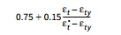 | (c) | 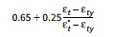 | (d)
ε_{t} ≥ (ε_{ty} + 0.003) | Tension-controlled³ | 0.9 | (e) | 0.9 | (f)
- For sections classified as transition, it shall be permitted to use φ corresponding to compression-controlled sections.
- ε_{t}* is the greater of net tensile strain calculated for P_{n} = 0.1A_{g}f _{c}' and (ε_{ty} + 0.003).
- For sections with factored axial compression force P_{u} ≥ 0.1A_{g}f _{c}', φ shall be calculated using equation (c) or (d) for sections classified as transition, as applicable.
1909.3.7 ACI 318, Section 25.2.10
Modify ACI 318 Section 25.2.10 as follows:
- 25.2.10 - For ties and hoops in columns to be placed with shotcrete, minimum clear spacing shall be 3 in. Shotcrete shall not be applied to spirally tied columns.
1909.3.8 ACI 318, Section 26.5.2
Modify ACI 318 Section 26.5.2.1 by replacing Items (l), (m) and (n) and adding item (q) as follows:
- (l) Shotcrete surfaces intended to receive subsequent shotcrete placement following an interruption of 30 minutes or more shall be roughened to a full amplitude of approximately ¹/₄ in. before the shotcrete has reached final set. The film of laitance which forms on the surface of the shotcrete shall be removed within approximately 2 hours after application by brushing with a stiff broom. If this film is not removed within 2 hours, it shall be removed by thorough wire brushing or a mechanical method acceptable to the enforcement agency.
- (m) Before placing additional material onto hardened shotcrete, laitance shall be removed, joints shall be cleaned and the surface shall be dampened. Construction joints over 8 hours old shall be thoroughly cleaned with air and water prior to receiving shotcrete.
- (n) In-place fresh concrete that exhibits sags, sloughs, segregation, honeycombing, sand pockets, or other obvious defects shall be removed and replaced. Shotcrete above sags and sloughs shall be removed and replaced while still plastic.
- (q) Surface preparation: Concrete or masonry to receive shotcrete shall have the entire surface thoroughly cleaned and roughened by a mechanical method acceptable to the enforcement agency, and just prior to receiving shotcrete, shall be thoroughly cleaned of all debris, dirt and dust. Concrete and masonry shall be brought to a saturated surface-dry (SSD) before shotcrete is deposited.
1909.3.9 ACI 318, Section 26.11.1.2
Modify ACI 318, Section 26.11.1.2 by adding Item (e) as follows:
- (e) Forms for shotcrete shall be substantial and rigid. Forms shall be built and placed so as to permit the escape of air and rebound. Adequate ground wires, which are to be used as screeds, shall be placed to establish the thickness, surface planes and form of the shotcrete work. All surfaces shall be rodded to these wires.
1909.3.10 ACI 318, Section 26.12.2.1
Modify ACI 318, Section 26.12.2.1 by replacing Item (a) as follows:
- Samples for strength tests of each class of concrete placed each day shall be taken not less than once a day, or not less than once for each 50 cubic yards (38.2 m³) of concrete, or not less than once for each 2,000 square feet (186 m²) of surface area for slabs or walls. Additional samples for seven-day compressive strength tests shall be taken for each class of concrete at the beginning of the concrete work or whenever the mix or aggregate is changed.
1909.4 Shotcrete
Shotcrete shall also conform to the provisions of ACI 506.2 and ACI 506R. The specified compressive strength of shotcrete shall not be less than 4,000 psi (27.6 MPa). Preconstruction tests of one or more shotcrete mockup panels prepared in accordance with Section 1705A.3.9.2 are required. In addition to testing requirements in ACI 318, special inspection and testing shall be in accordance with Section 1705A.3.9. The evaluation of the shotcrete mockup panel to qualify bar clearance dimensions in accordance with ACI 318 Section 25.2.7 or contact lap splices in accordance with ACI 318 Section 25.5.1.7 shall be in accordance with the requirements of ACI 506.4R with a core quality category of Very Good given in ACI 506.6T. Tolerances for shotcrete construction shall be defined by the construction documents.
1909.5 Existing Concrete Structures
The structural use of existing concrete with a core strength less than 1,500 psi (10.3MPa) is not permitted in rehabilitation work.
For existing concrete structures, sufficient cores shall be taken at representative locations throughout the structure, as designated by the architect or structural engineer, so that knowledge will be had of the in-place strength of the concrete. At least three cores shall be taken from each building for each 4,000 square feet (372 m²) of floor area, or fraction thereof. Cores shall be at least 4 inches (102 mm) in diameter. Cores as small as 2.75 inches (70 mm) in diameter may be allowed by the enforcement agency when reinforcement is closely spaced and the coarse aggregate does not exceed ³/₄ inch (19 mm).
Section 1910 Additional Requirements for Skilled Nursing Facilities, Intermediate Care Facilities, Acute Psychiatric and Non-GAC Buildings [OSHPD 1R, 2 & 5]
1910.1 General
1910.1.1 Construction Documents
Openings larger than 12 inches (305 mm) in any dimension shall be detailed on the structural drawings.
1910.2 Tests and Materials
Where required, special inspections and tests shall be in accordance with Chapter 17 and this section.
1910.2.1 Cementitious Material
The concrete supplier shall furnish to the enforcement agency certification that the cement proposed for use on the project has been manufactured and tested in compliance with the requirements of ASTM C150 for Portland cement and ASTM C595 or ASTM C1157 for blended hydraulic cement, whichever is applicable. When a mineral admixture or ground granulated blast-furnace slag is proposed for use, the concrete supplier shall furnish to the enforcement agency certification that they have been manufactured and tested in compliance with ASTM C618 or ASTM C989, whichever is applicable. The concrete producer shall provide copies of the cementitious material supplier's certificate of compliance that represents the materials used by date of shipment for concrete. Cementitious materials without certification of compliance shall not be used.
1910.2.2 Tests of Reinforcing Bars
Samples shall be taken from bundles as delivered from the mill, with the bundles identified as to heat number and the accompanying mill certificate. One tensile test and one bend test shall be made from a sample from each 10 tons (9080 kg) or fraction thereof of each size of reinforcing steel.
Where positive identification of the heat number cannot be made or where random samples are to be taken, one series of tests shall be made from each 2¹/₂ tons (2270 kg) or fraction thereof of each size of reinforcing steel.
Tests of reinforcing bars may be waived by the structural engineer with the approval of the building official for one-story buildings or nonbuilding structures, provided that they are identified in the construction documents and certified mill test reports are provided to the inspector of record for each shipment of such reinforcement.
1910.2.3 Tests for Prestressing Steel and Anchorage
All wires or bars of each size from each mill heat and all strands from each manufactured reel to be shipped to the site shall be assigned an individual lot number and shall be tagged in such a manner that each lot can be accurately identified at the job site. Each lot of tendon and anchorage assemblies and bar couplers to be installed shall be likewise identified.
The following samples of materials and tendons selected by the engineer or the designated testing laboratory from the prestressing steel at the plant or job site shall be furnished by the contractor and tested by an approved independent testing agency:
- For wire, strand or bars, 7-foot-long (2134 mm) samples shall be taken of the coil of wire or strand reel or rods. A minimum of one random sample per 5,000 pounds (2270 kg) of each heat or lot used on the job shall be selected.
- For prefabricated prestressing tendons other than bars, one completely fabricated tendon 10 feet (3048 mm) in length between grips with the anchorage assembly at one end shall be furnished for each size and type of tendon and anchorage assembly.
  - Variations of the bearing plate size need not be considered.
  - The anchorages of unbonded tendons shall develop at least 95 percent of the minimum specified ultimate strength of the prestressing steel. The total elongation of the tendon under ultimate load shall not be less than 2 percent measured in a minimum gage length of 10 feet (3048 mm).
  - Anchorages of bonded tendons shall develop at least 90 percent of the minimum specified strength of the prestressing steel tested in an unbonded state. All couplings shall develop at least 95 percent of the minimum specified strength of the prestressing steel and shall not reduce the elongation at rupture below the requirements of the tendon itself.
- If the prestressing tendon is a bar, one 7-foot (2134 mm) length complete with one end anchorage shall be furnished and, in addition, if couplers are to be used with the bar, two 4-foot (1219 mm) lengths of bar fabricated to fit and equipped with one coupler shall be furnished.
- Mill tests of materials used for end anchorages shall be furnished. In addition, at least one Brinnell hardness test shall be made of each thickness of bearing plate.
1910.2.4 Composite Construction Cores
Cores of the completed composite concrete construction shall be taken to demonstrate the shear strength along the contact surfaces. The cores shall be tested when the cast-in-place concrete is approximately 28 days old and shall be tested by a shear loading parallel to the joint between the precast concrete and the cast-in-place concrete. The minimum unit shear strength of the contact surface area of the core shall not be less than 100 psi (689 kPa).
At least one core shall be taken from each building for each 5,000 square feet (465 m²) of area of composite concrete construction and not fewer than three cores shall be taken from each project. The architect or structural engineer in responsible charge of the project or his or her representative shall designate the location for sampling.
1910.3 Modifications to ACI 318
1910.3.1 ACI 318, Section 12.7.3
Add Section 12.7.3.4 to ACI 318 as follows:
12.7.3.4 — At least two No. 5 bars in diaphragms having two layers of reinforcement in both directions and one No. 5 bar in diaphragms having a single layer of reinforcement in both directions shall be provided around openings larger than 12 inches in any dimension in addition to the minimum reinforcement required by Section 12.6.
1910.3.2 ACI 318, Section 18.12.6
Add Section 18.12.6.2 to ACI 318 as follows:
Collector and boundary elements in topping slabs placed over precast floor and roof elements shall not be less than 3 inches (76 mm) or 6 d_{b} thick, where d_{b} is the diameter of the largest reinforcement in the topping slab.
1910.3.3 ACI 318, Table 19.2.1.1
Modify ACI 318 Table 19.2.1.1 as follows:
For concrete designed and constructed in accordance with this chapter, f '_{c,}, shall not be less than 3,000 psi (20.7 MPa). Reinforced normal weight concrete with specified compressive strength higher than 8,000 psi (55 MPa) shall require prior approval of structural design method and acceptance criteria by the enforcement agency.
1910.3.4 ACI 318, Section 26.11.1.2
Modify ACI 318 Section 26.11.1.2 by adding Item (e) as follows:
- (e) Forms for shotcrete shall be substantial and rigid. Forms shall be built and placed so as to permit the escape of air and rebound. Adequate ground wires, which are to be used as screeds, shall be placed to establish the thickness, surface planes and form of the shotcrete work. All surfaces shall be rodded to these wires.
Section 1911 Existing Concrete Structures [OSHPD 1R, 2 & 5]
1911.1 Concrete Core Sampling
Where concrete cores are required to be taken for material property determination, cores shall be at least 4 inches (102 mm) in diameter. Cores as small as 2.75 inches (70 mm) in diameter may be allowed by the enforcement agency when reinforcement is closely spaced and the coarse aggregate does not exceed ³/₄ inch (19 mm).
1911.2 Crack Repair by Epoxy Injection
Crack Repair of concrete and masonry member by epoxy injection shall conform to all requirements of ACI 548.15.
1911.3 Concrete Strengthening by Externally Bonded Fiber Reinforced Polymer (FRP)
Design and construction of externally bonded FRP systems for strengthening concrete structures shall be in accordance with ACI 440.2R.
Exceptions:
- Near-Surface Mounted (NSM) FRP bars shall not be permitted.
- Strengthening of shear walls and diaphragms (including chords and collectors) shall be considered as an alternative system.
Design capacities, reliability and serviceability of FRP materials shall be permitted to be established in accordance with ICC-ES AC 125. Minimum inspection requirements of FRP composite systems shall be in accordance with ICC-ES AC 178.

